
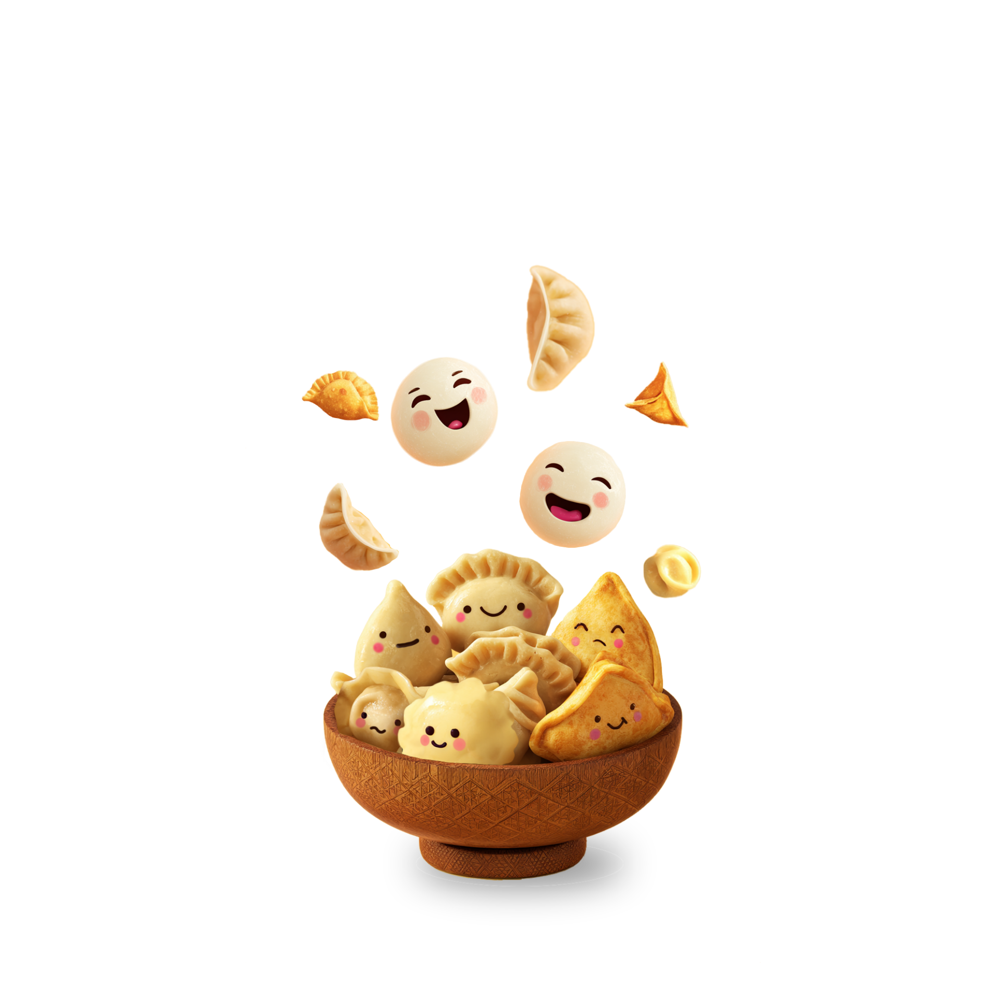

Social Story

Dumplings Against Depression
Uniting Cultures for Mental Wellbeing


Acknowledgement of Country
We acknowledge the Traditional Custodians of the land on which this event will be held, the Wurundjeri people of the Kulin Nation.
As people from many cultures coming together, we pay our respects to their Elders past and present. We recognise this is a place where deep age-old knowledge of land continues to be held and embedded in Aboriginal Community and custodianship of Country.




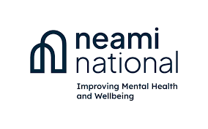
This social story was developed with the support of Neami National.

What is Dumplings Against Depression: Uniting Cultures for Mental Wellbeing?

Dumplings Against Depression is a 1-day event that brings together people from many cultures over a much-loved food – dumplings.
It’s a community gathering where we’ll share conversations about mental health and wellbeing, presentations and activities.

The event is hosted by the Victorian Multicultural Commission, in partnership with:
- Solis, a network of mental health professionals and advocates, and
- the Victorian Collaborative Centre for Mental Health and Wellbeing.

People from any culture are welcome to join. Many of us have our own lived experience of mental health challenges and emotional distress. This includes people on our event team who have contributed to planning the day.


Registration

I registered for this event online https://events.humanitix.com/dumplings-against-depression-uniting-cultures-for-mental-wellbeing through Humanitix webpage.

I shared my dietary requirements when I registered.
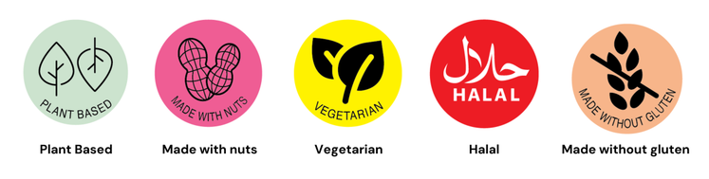

Attending the event
I am going to the Immigration Museum on Flinders Street to attend Dumplings Against Depression: Uniting Cultures for Mental Wellbeing.
The event is for one day, Saturday 8 November starting at 11:15 am
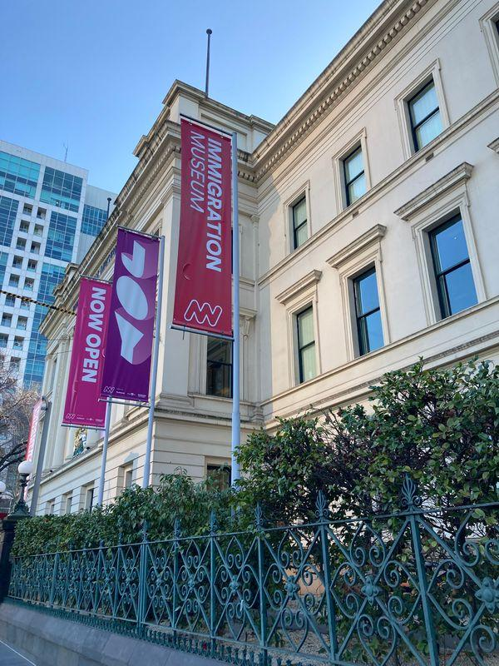

Activities
There are different activities I can participate in.
I can choose to:
- listen to a panel discussion
- speak with people who work in cultural and mental health services
- take part in dancing
- take a tour of an art exhibition
- eat dumplings or other food served at the event
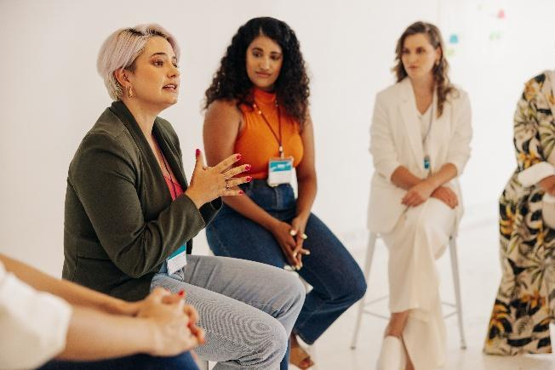 | 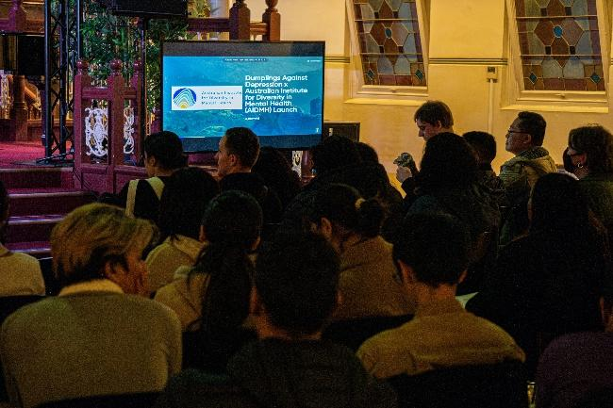
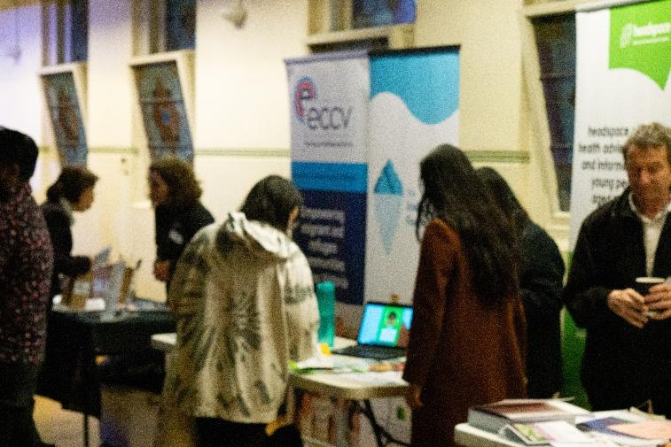 | 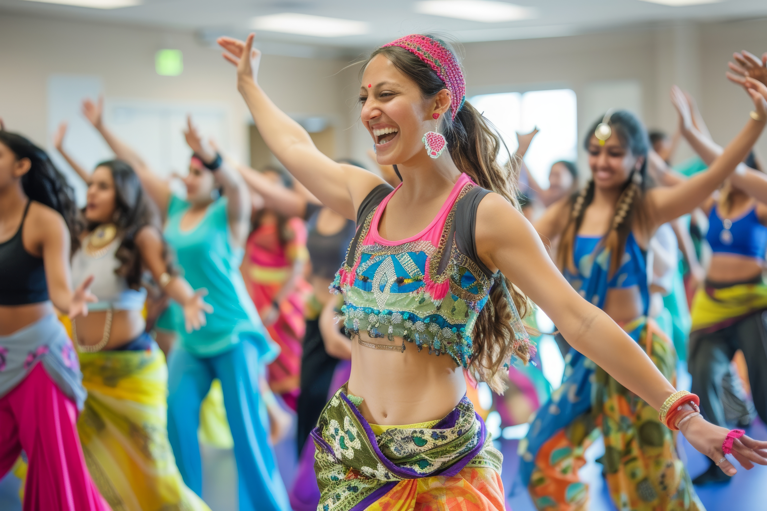
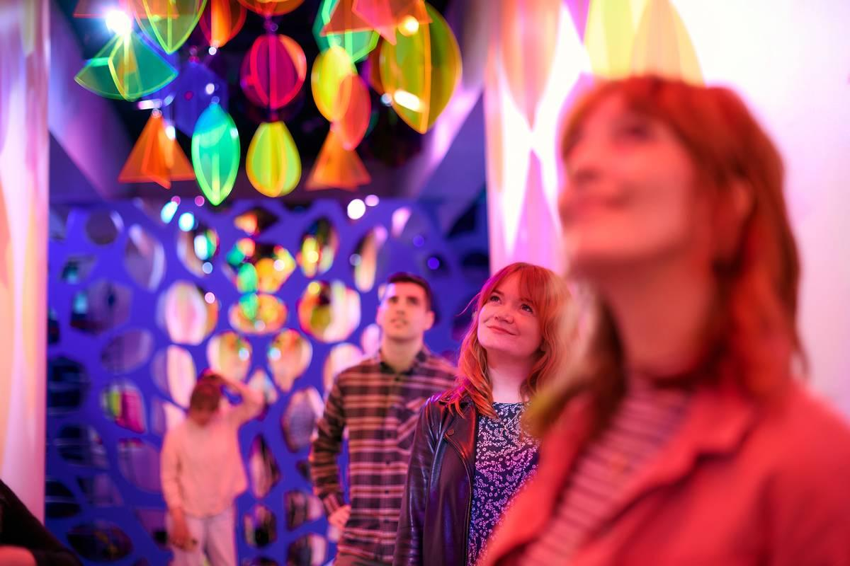
Arriving
I can enter the museum from the front entrance on Flinders Street. The doors at the top of the stairs will open automatically for me.
If I use a side entrance on Market Street or Williams Street, there are no stairs. These pathways will lead me to the back of the building, or around to the front entrance.
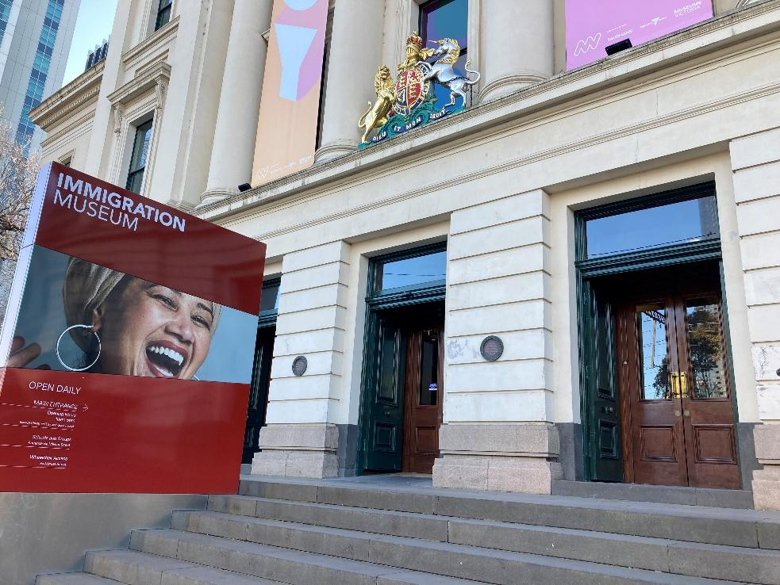

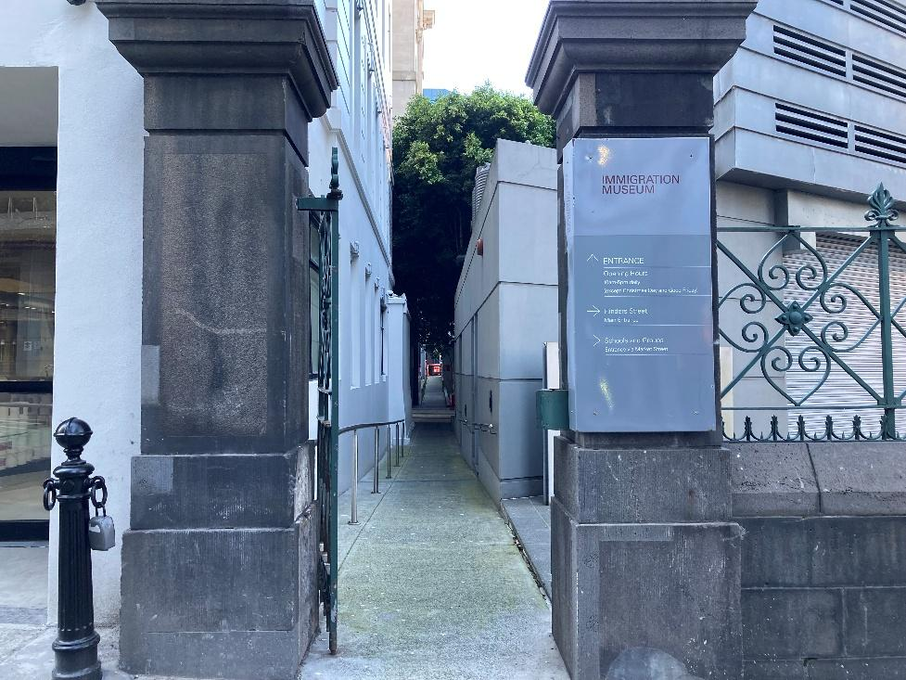
Back entrance
If I enter through the back of the building, I will walk through a colourful corridor to the front foyer.
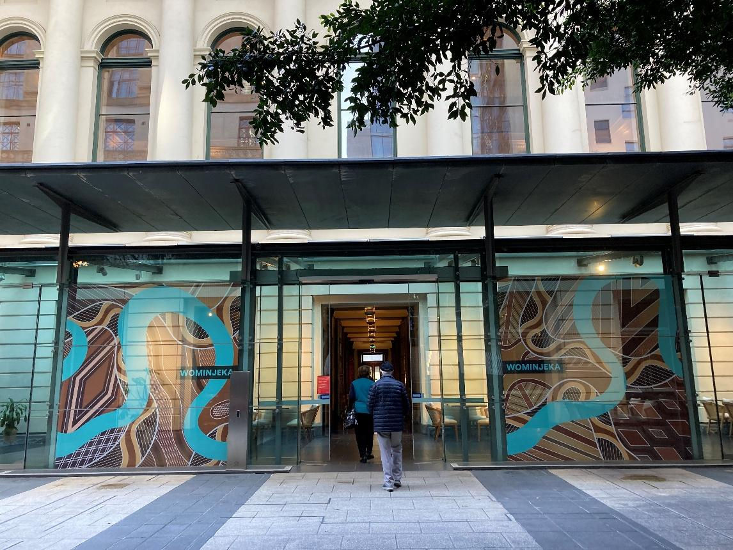
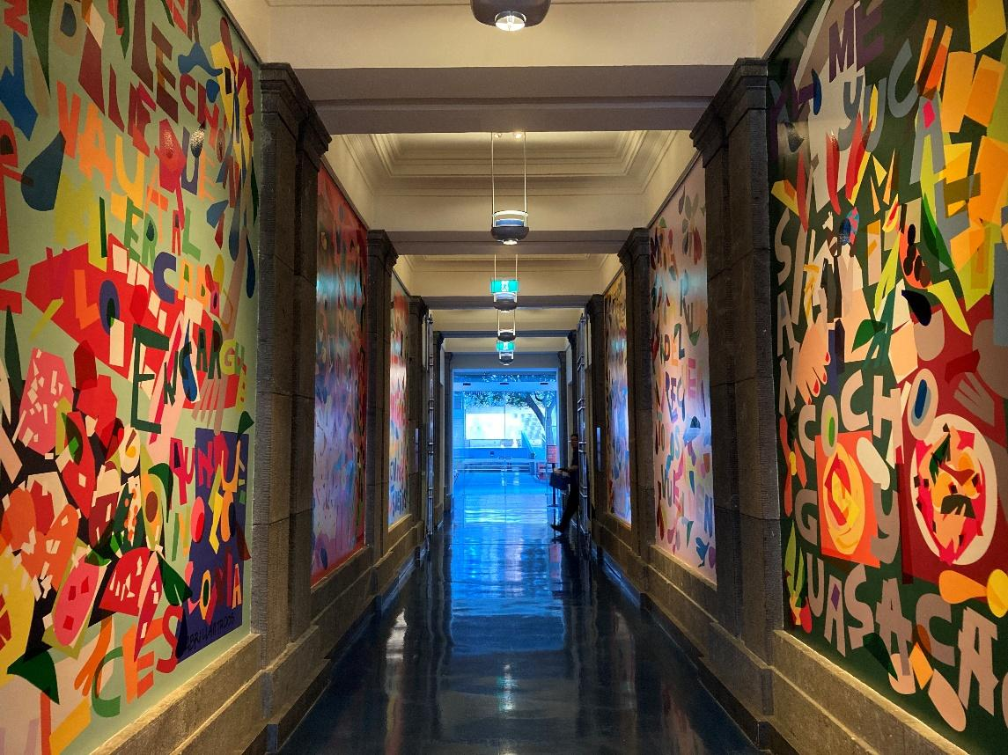
Registration
I’ll go to the front desk inside the foyer. A staff member will check my ticket and give me a wristband.
There might be photographers at the event. If I don’t want to have my photo taken, I can ask for a pink wristband.
Wearing a pink wristband shows photographers that I do not want to be photographed.
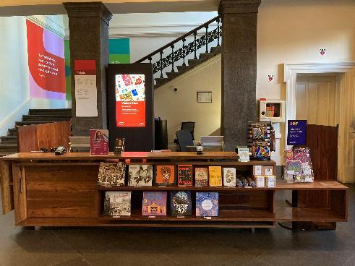
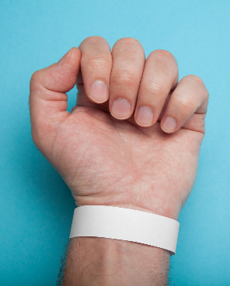
Going up to the event
The event is on Level 1. I can go up using the stairs or take the lift.

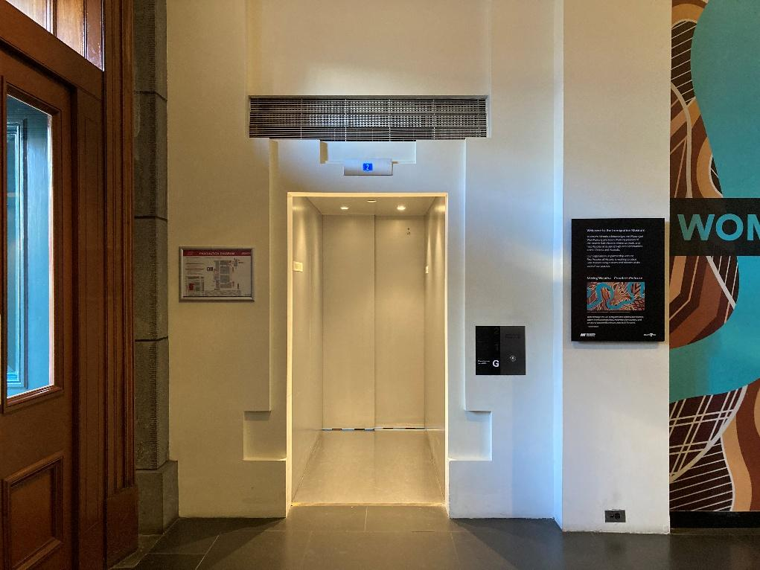
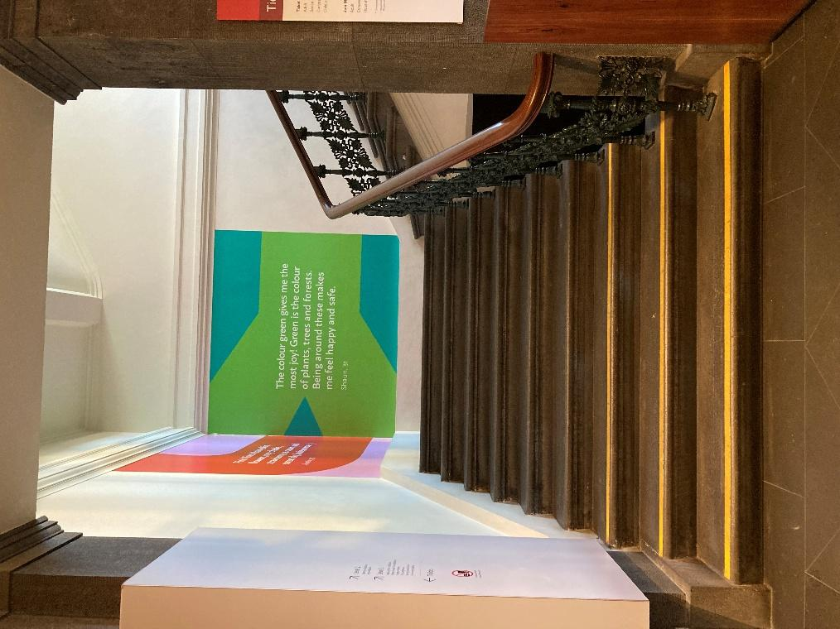
Toilets
I can find accessible toilets on the Ground Floor and Level 1.
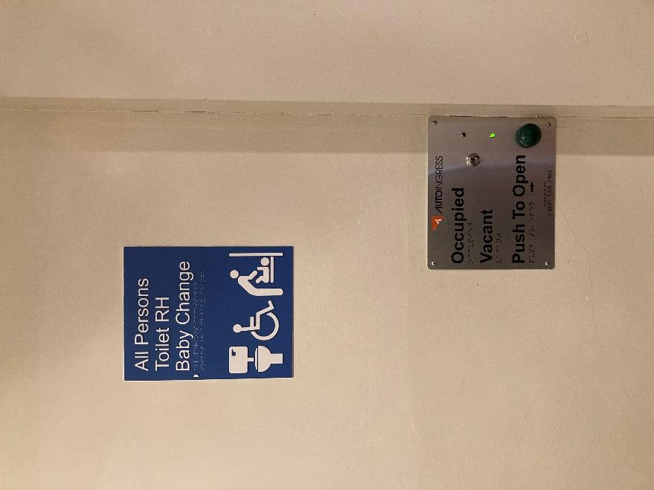
I can use the baby change facilities if I need to.
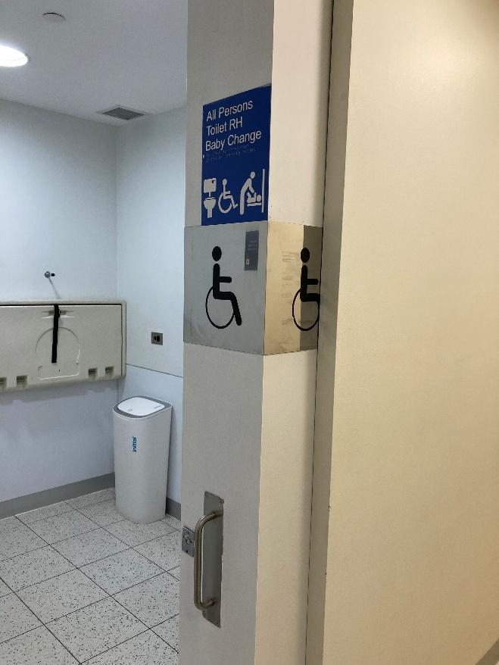

Event space
The event will be held in the Long Room on Level 1.
I can sit down if I want to, or choose to stand.
I might be part of a crowd of people listening to presenters.
There will be stalls with information, where I can talk to people who work in cultural and mental health services.
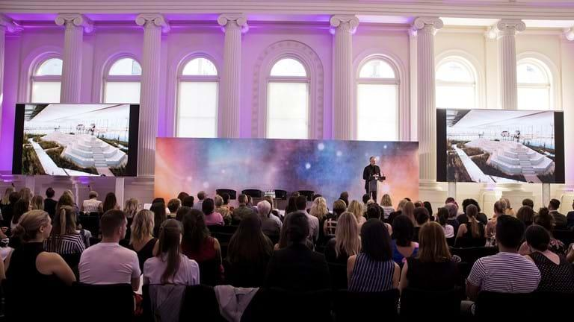 | 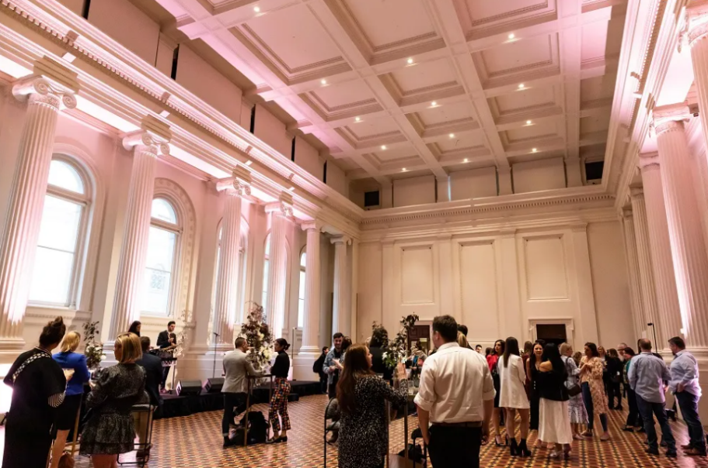
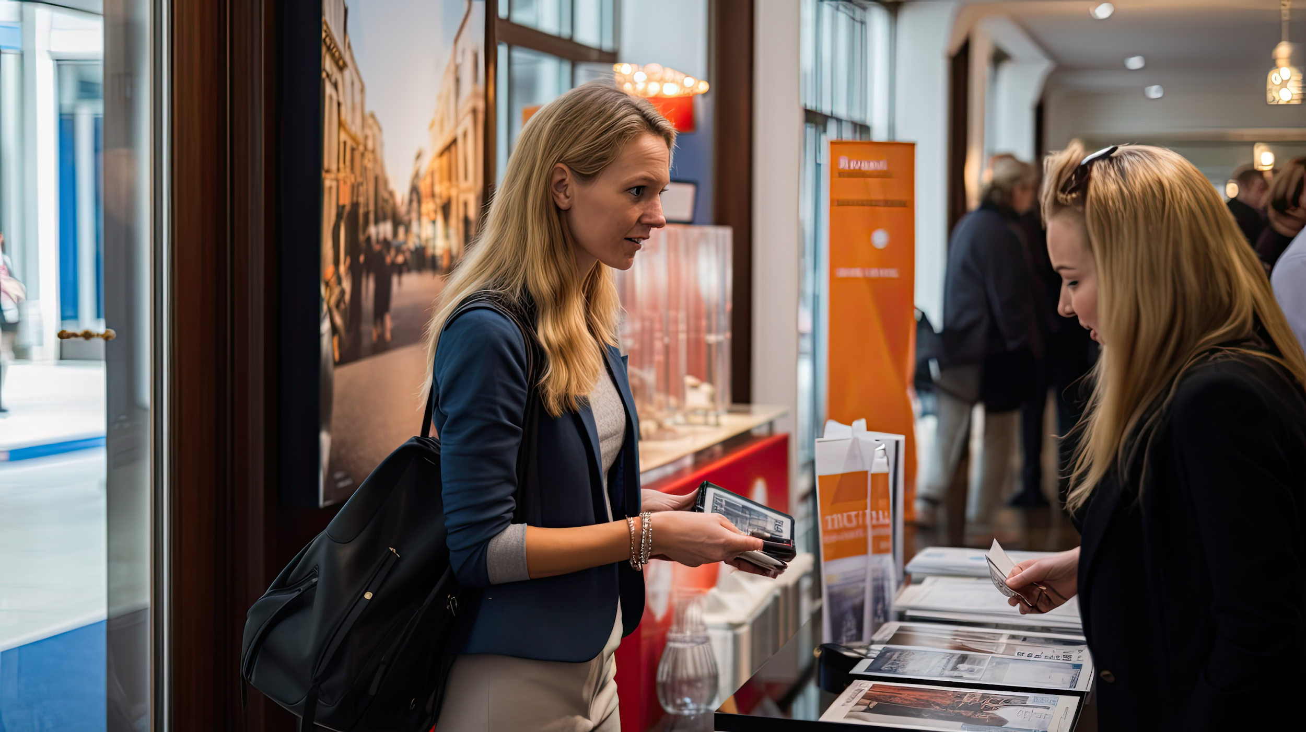 | 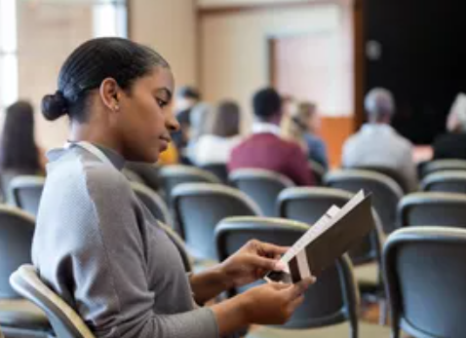

Food and drink
I can eat dumplings or other food served at the event. I can also choose to bring my own food.
There will be water, tea and coffee available to me if I want some.

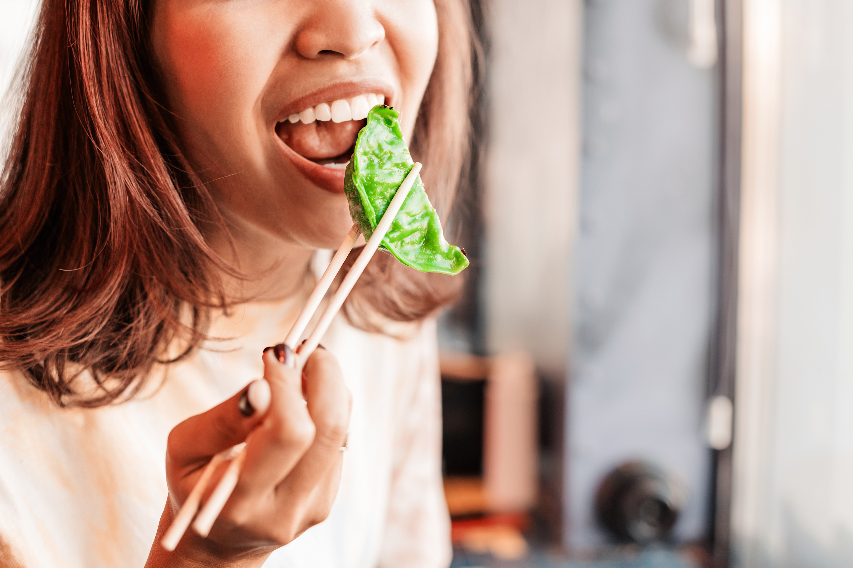
Program
A program of activities will be displayed at the event.
I can also find it online here: https://co-design.link/dad

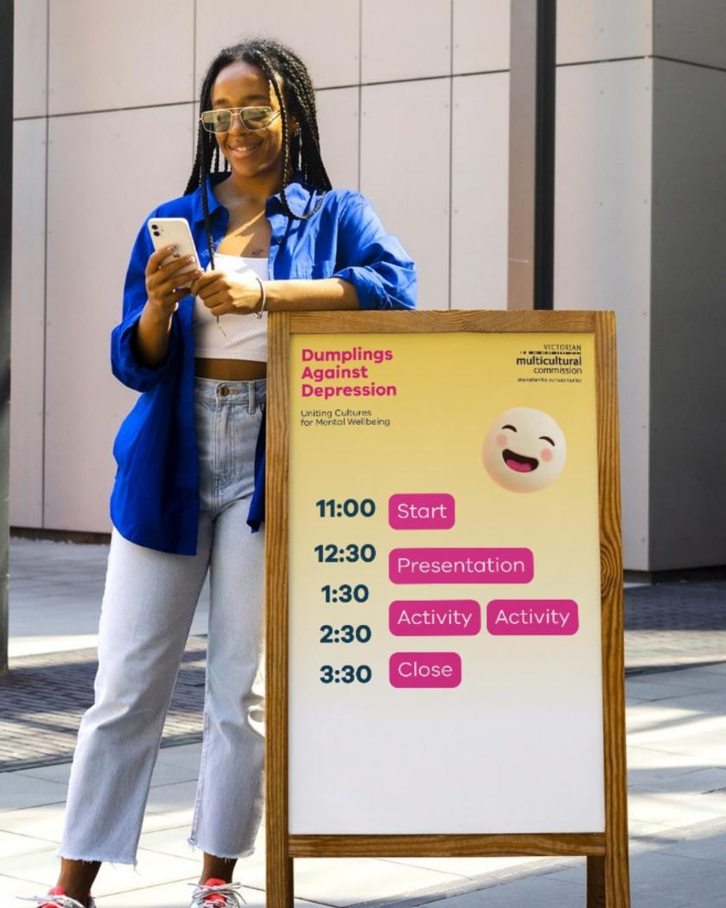
Taking a break
It could feel noisy and crowded, with people talking into a microphone and audience members clapping.
There could be music or physical movement during the interactive sessions. I can choose to join in or watch other people participate.
People will talk about mental health and wellbeing. I can ask staff for support if I don’t feel comfortable. My thoughts, feelings, experiences and choices will be respected.
With my event wristband, I can leave and come back at any time during the event.
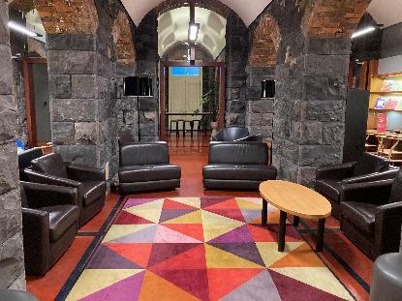
I can take a break in the Discovery Centre on the Ground Floor, or go outside where there are plants and more seating areas.
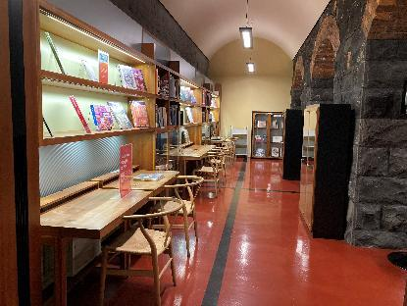
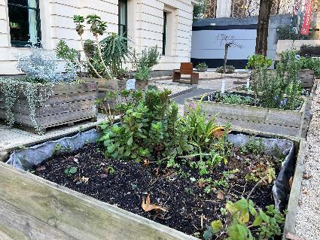

Prayer room
I can use the prayer room on Level 1 at any time during the event. I can ask a staff member if I need help to find it.
Inside the prayer room, I will see tables and chairs, and space on the floor that I can use.
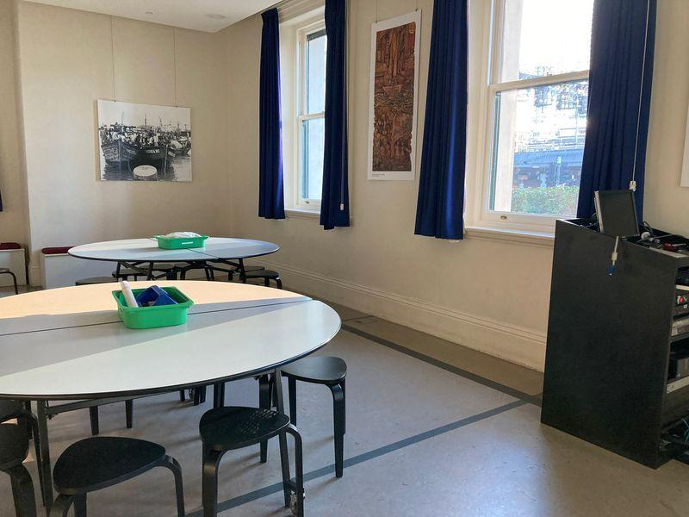

Joy
If I take a tour of the Joy exhibition, I’ll see colourful artworks. They were produced by artists from different cultures and explore the theme of joy.
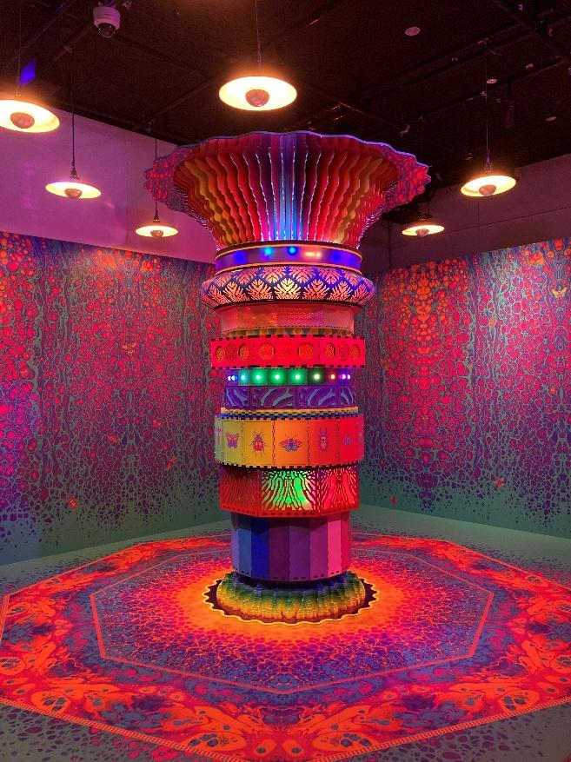
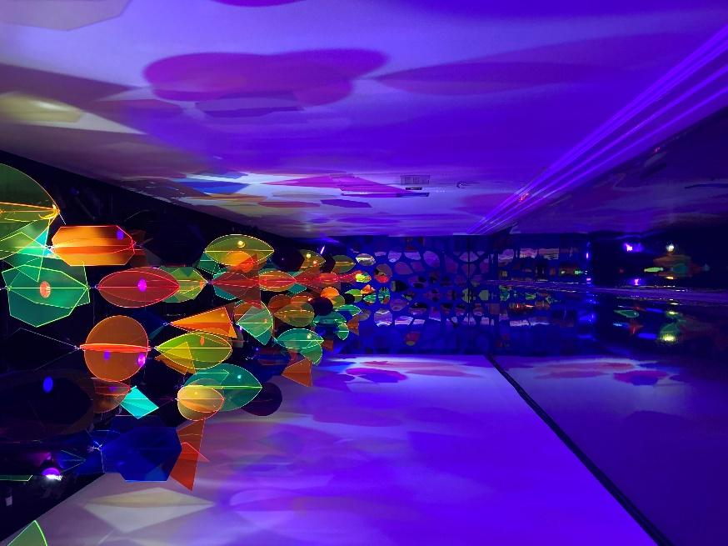

More information
I can find more accessibility information on the Immigration Museum website

Contact us
I can email my questions to events@vmc.vic.gov.au 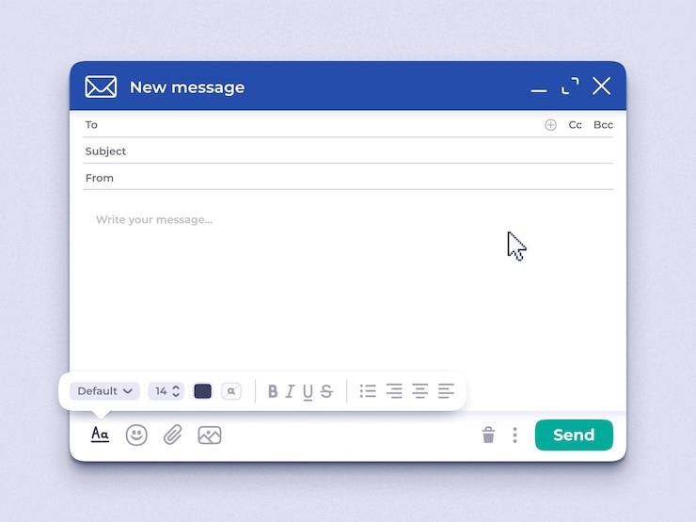
Or call 0439 770 306


Feedback
I will be emailed a survey after the event asking for my feedback.
I can choose to share my experience anonymously or identify myself.
